Spcm lab 9

**Lab Exercise 9– Creating Multiple EC2 Instances with for_each in Terraform**

**Objective:**

Learn how to use for_each in Terraform to create multiple AWS EC2 instances with specific settings for each instance.

**Prerequisites:**

* Terraform installed on your machine.
* AWS CLI configured with the necessary credentials.

**Steps:**

1. **Create a Terraform Directory:**

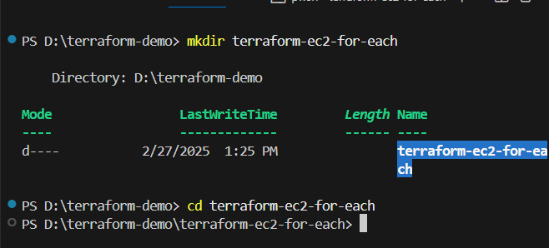

**# main.tf**

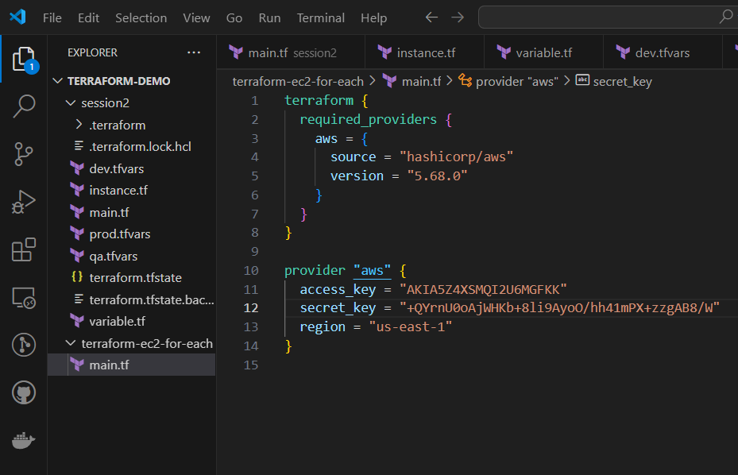

**#Var.tf**

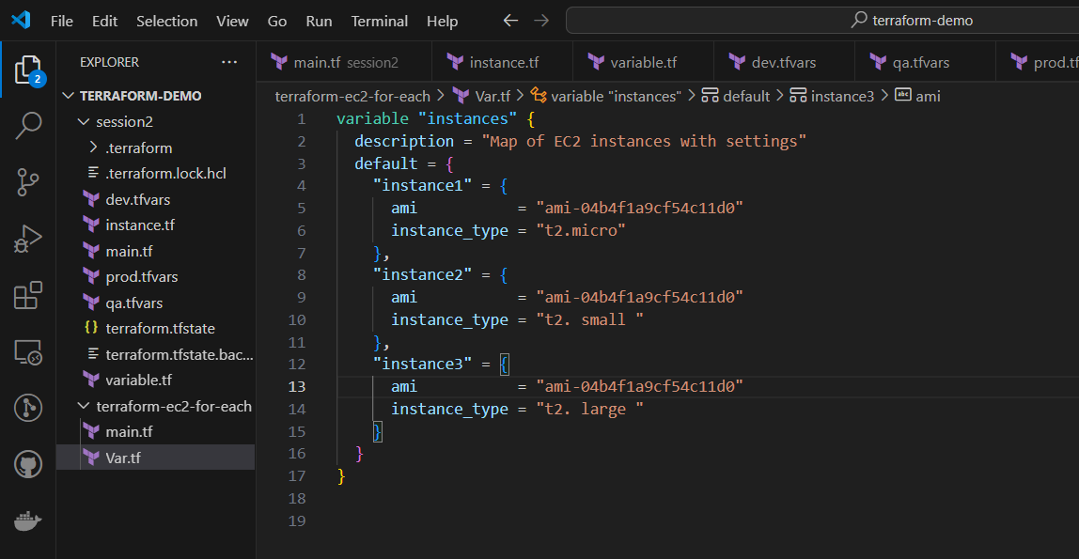

**#Instance.tf**

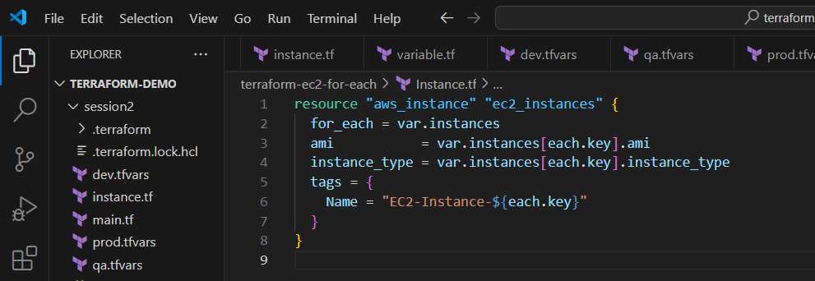

init

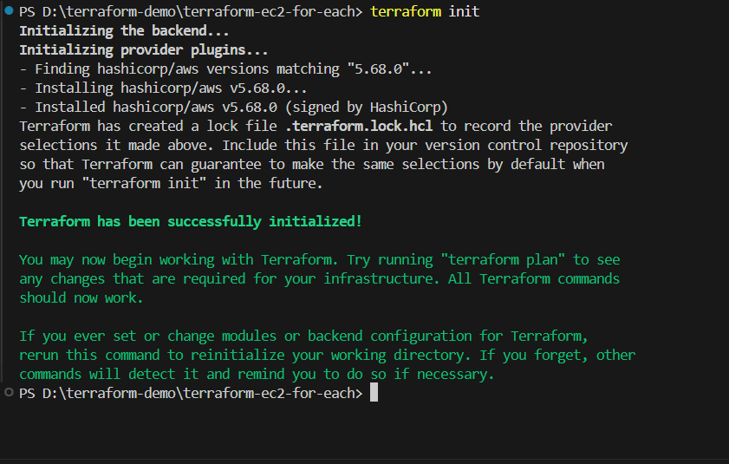

apply

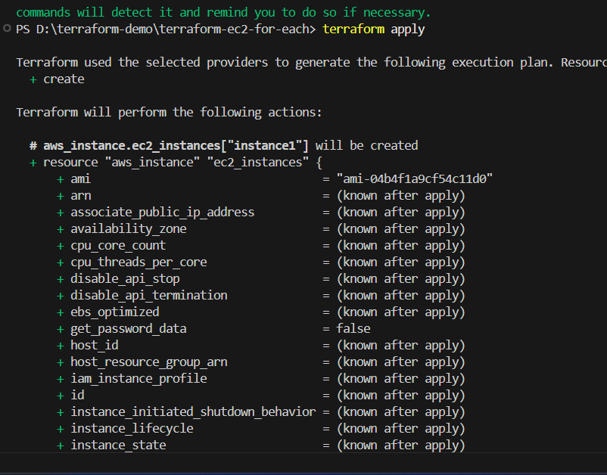

Intance running

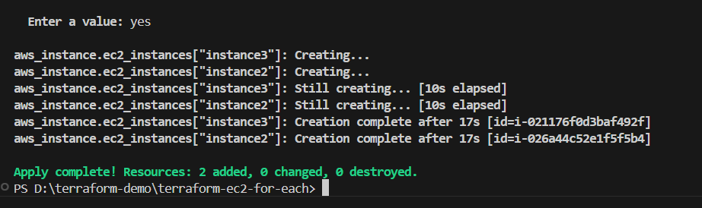

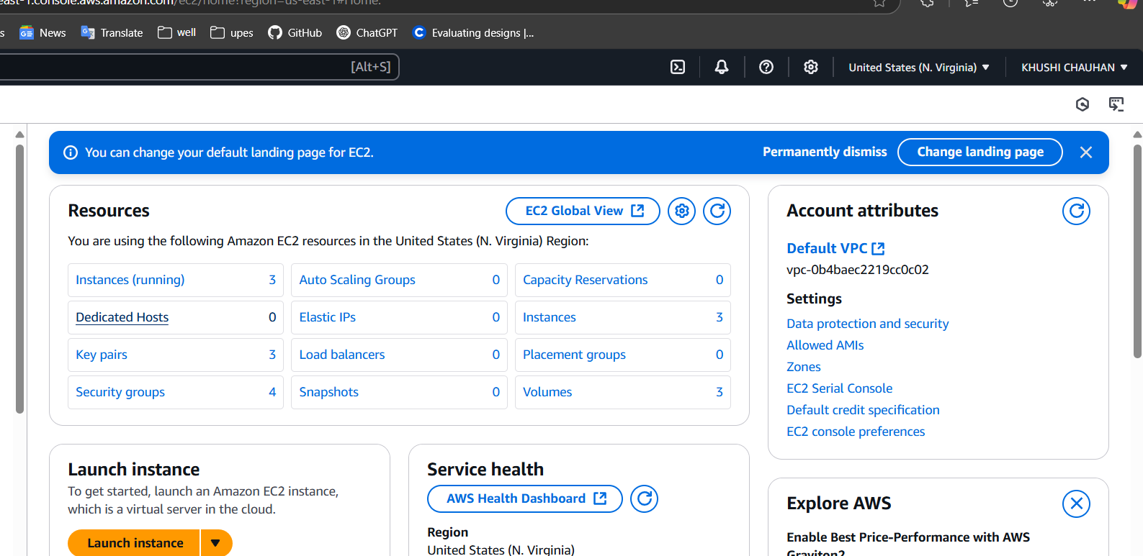

Destroy

